**Lab Submission 06**

**Table Partitioning**

**Instructor: Basit Ali**

Which column(s) in default.employees is suitable for partitioning?  
1**. Create a new table employees_copy with partition.**

CREATE TABLE employees_by_office_id (emp_id int, first_name STRING, last_name STRING, Salary int)

PARTITIONED BY (Office_id STRING)

ROW FORMAT DELIMITED

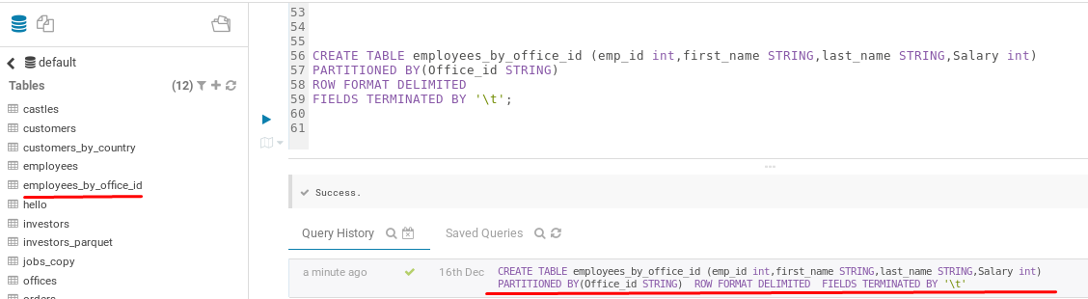FIELDS TERMINATED BY '\t';

**2. Insert data into that partitioned table.**

INSERT OVERWRITE TABLE employees_by_office_id

PARTITION (office_id)

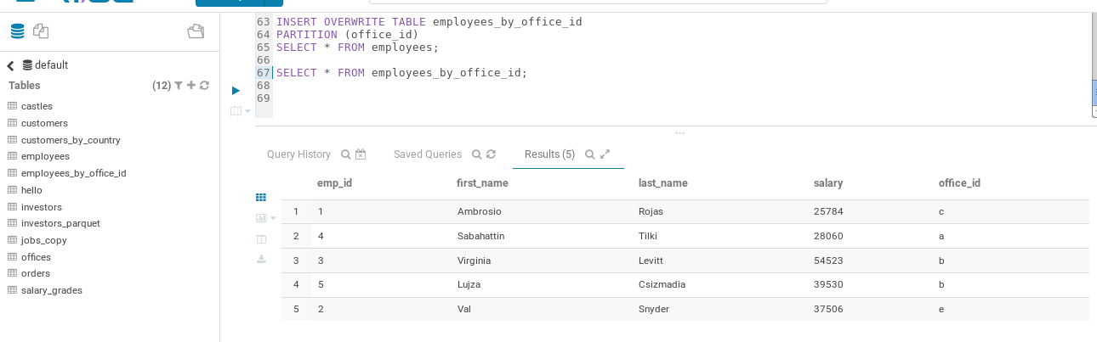SELECT * FROM employees;

**3. View the data in hdfs>hive>warehouse**



